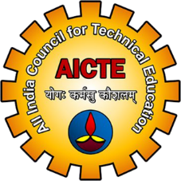
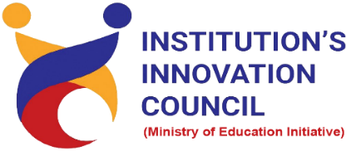

The Journey of Innovation to IPR
30 June 2022
At
Virtually on Webex
Saurashtra University Campus, Rajkot
Contents
Saurashtra University – IIC 2
Event Schedule 2
Event Registration Link 2
Brief about Event 3
Key Points 3
Outcome 3
About the Speaker/Chief Guest 4
Connect Us: 5

Saurashtra University – IIC
The university is dedicated to instruction, research, and extending knowledge to the public (public service). Ministry of Education (MoE), Govt. of India has established ‘MoE’s Innovation Cell (MIC)’ to systematically foster the culture of Innovation among all Higher Education Institutions (HEIs). The primary mandate of MIC is to encourage, inspire and nurture young students by supporting them to work with new ideas and transform them into prototypes while they are informative years. Saurashtra University is one the Organization that have constituted the IIC to foster the vision of MoE and be a part for the promotion and development of innovation ecosystem.

Event Schedule

Event Registration Link

bit.ly/ImpactSeries-IIC

Brief about Event
Saurashtra University is Organizing Impact Lecture Series with support of Ministry of Education, Government of India. The objective of Impact Lecture Session is to support students from hilly/rural/backward regions or 3rd tier cities by organizing impact lectures to establish a strong connection with the innovation and start up ecosystem enablers at the state and national levels.
The webinar’s objective is to gain insights about Innovation, Invention, IPR, Patent, Trademark and Trade secrets. This involves What is Innovation, Difference between innovation and invention, types of IP involve understood with various types of examples. In this webinar discuss about how to identify IP, which stages IP needs to protect and what to protect is very important. In this webinar also understood when to file a Patent and when not to file a Patent.
After completion of the webinar, participants are able to acquire more knowledge on The Journey of Innovation to IPR.

Key Points

During the session, below mentioned points were discussed:
- What is Innovation
- Innovation and IPR
- Types of IP involves
- Patent v/s Trade secret
- Patent or Publications?
- Trademark and copyright
- Design registration
- FAQs related to The Journey of Innovation to IPR.

Outcome
As per the event, various type of IP involves, how to file Design registration, when to file a design application, when to file a trademark application and Importance of Patent was made understood by the speaker.
Also, understood file a patent first then goes for publication. It was related to Journey of Innovation to IPR so, various innovation and IPR understood by the speaker with various examples etc.

About the Speaker/Chief Guest

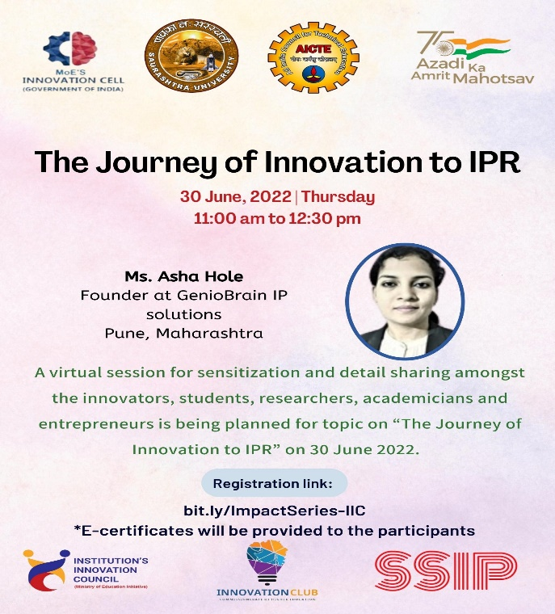

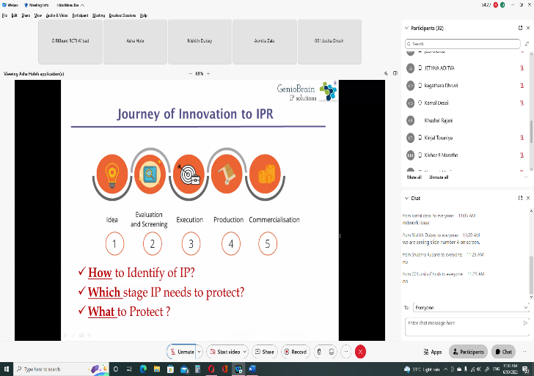
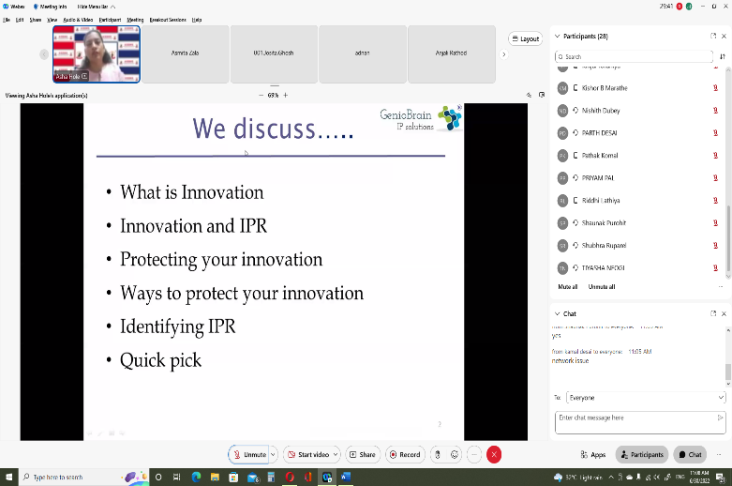

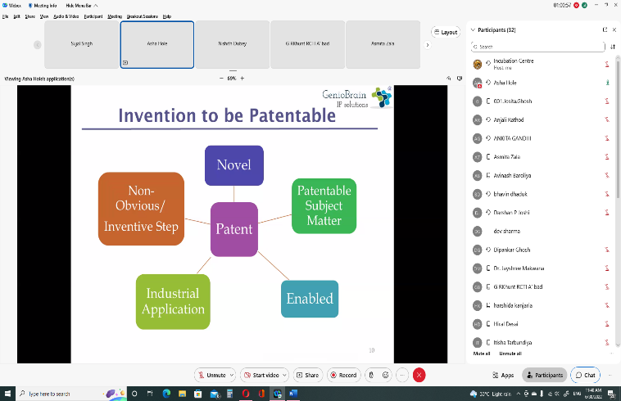
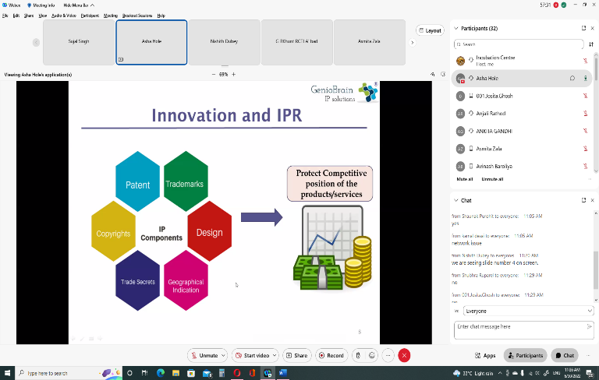

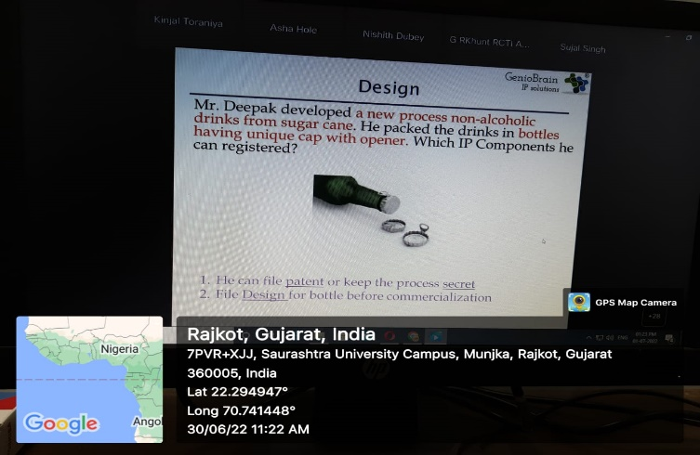
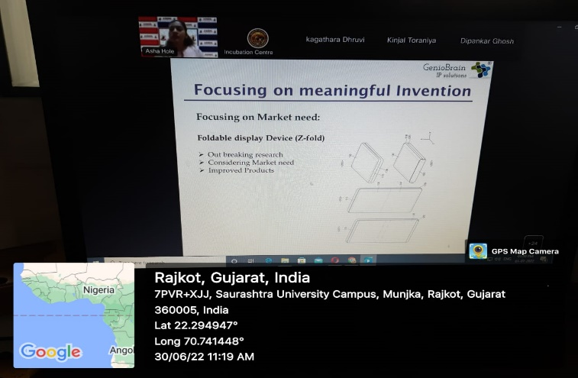

Connect Us:

https://www.linkedin.com/company/susec iic@sauuni.ac.in
https://www.facebook.com/iicsauuni bit.ly/SU-SSIP Location
https://www.instagram.com/susecrajkot https://bit.ly/SUSEC-youtube

